Simulation ani models ko definition

* Simulation is the imitation of the operation of a real-world process or

system over time in a controlled environment for the modification or adjusting of the variables as needed.

* basically, it’s a model that mimics the operation of an existing or proposed system at different scenarios or process changes.
* **Don’t have to spend time (or money) building and testing multiple prototypes. You can settle on a design that satisfies the requirements in simulation before building an actual prototype**

**A general-purpose simulation package can be used for any**

**application, but might have special features for certain ones (like**

**manufacturing, communications, or business process**

**reengineering).**

**Arena**

* **Arena is a**[**discrete event simulation**](https://en.wikipedia.org/wiki/Discrete_event_simulation)**and**[**automation**](https://en.wikipedia.org/wiki/Automation)**software developed by Systems Modeling and acquired by**[**Rockwell Automation**](https://en.wikipedia.org/wiki/Rockwell_Automation)**in 2000.**
* **Arena is a simulation software product that provides an integrated framework for building simulation models in a wide variety of applications.**
* Based on discrete event modelling, Arena models are developed using a well-defined flowchart-based modelling methodology with an extensive library of standard modules.

**An application-oriented simulation package is designed to be**

**used for a certain class of application (like manufacturing, health**

**care, or call centers). Manufacturing Automod (banks and brooks) , medmodel (healthcare)**

**Medmodel**

* **a powerful Windows-based simulation tool for simulating and analyzing health care systems of all types and sizes.**
* MedModel focuses on issues such as resource utilization, system capacity, and capability. By modeling the important elements of a health care system, you can experiment with different operating strategies and designs to achieve the best results.
* **provides the perfect combination of ease-of-use and complete flexibility and power for modeling nearly any situation, and its realistic animation capabilities makes simulation come to life.**

Typical applications for using MedModel include:

* Facility planning
* Health care policy formulation
* Staffing & equipment requirements planning
* Disaster planning
* Managed care analysis

**Features:**

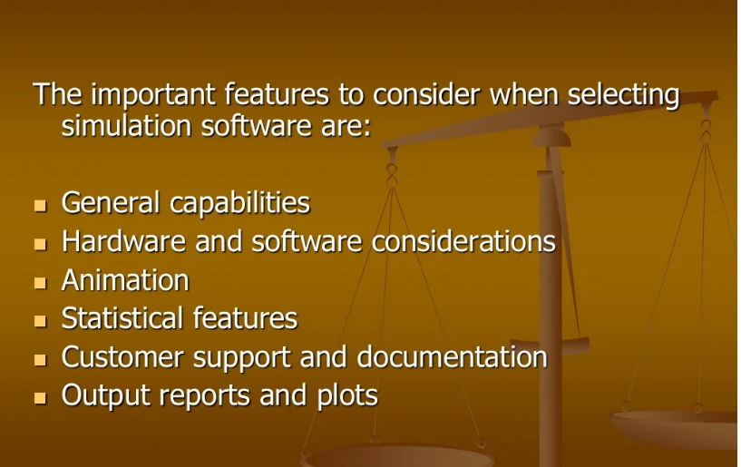

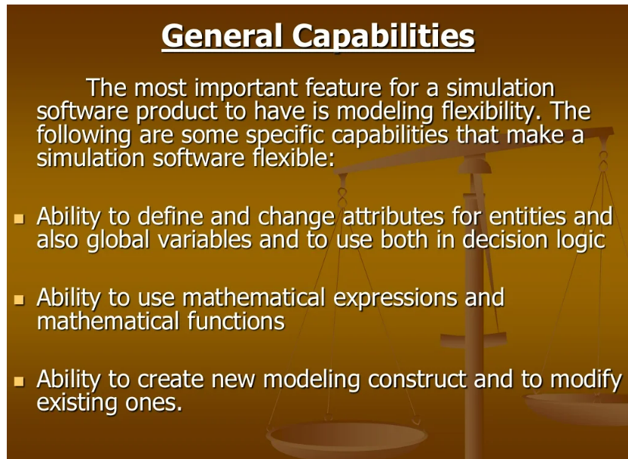

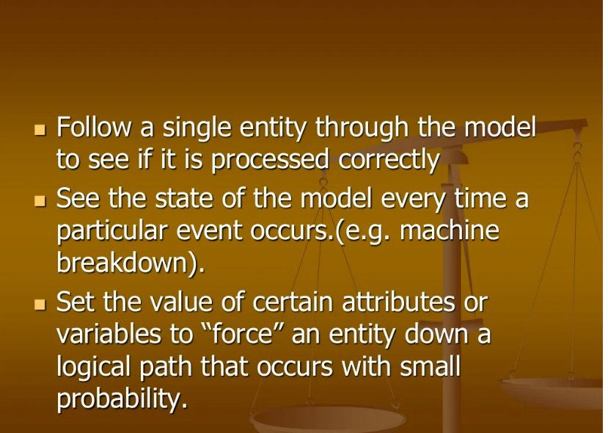

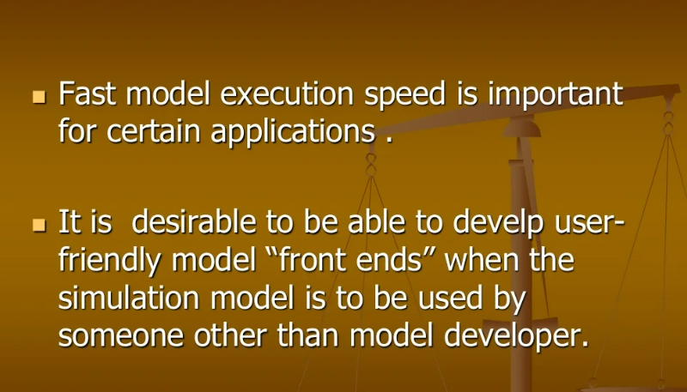

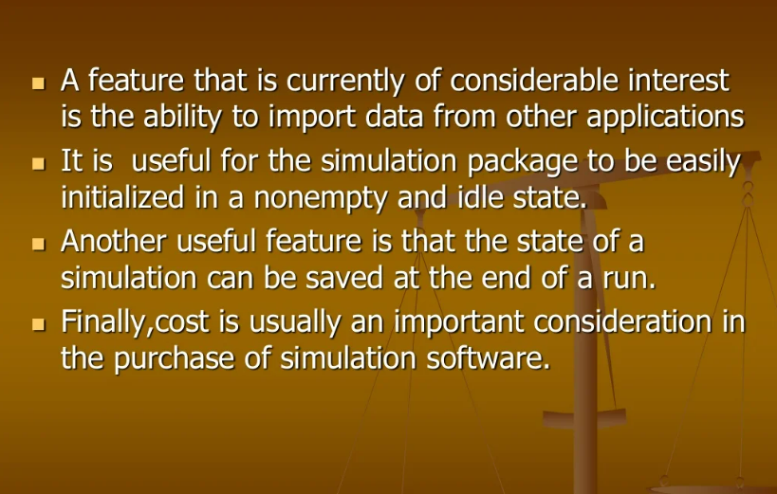

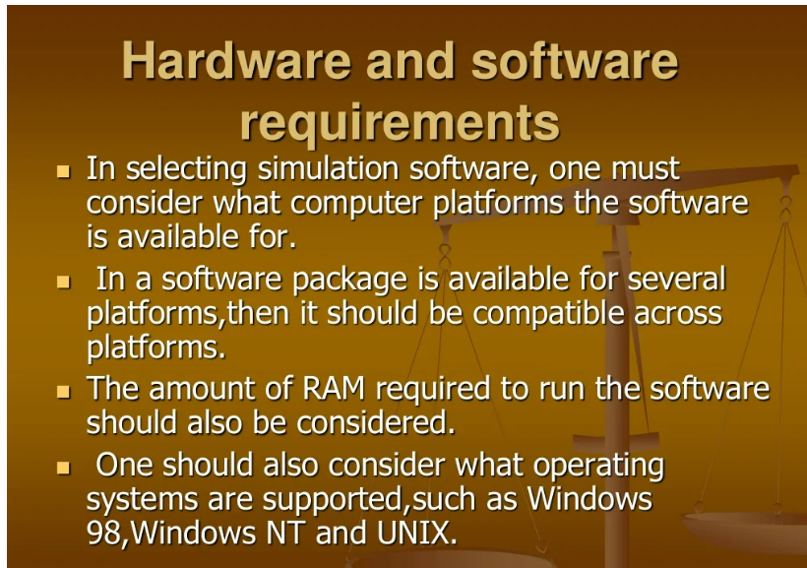

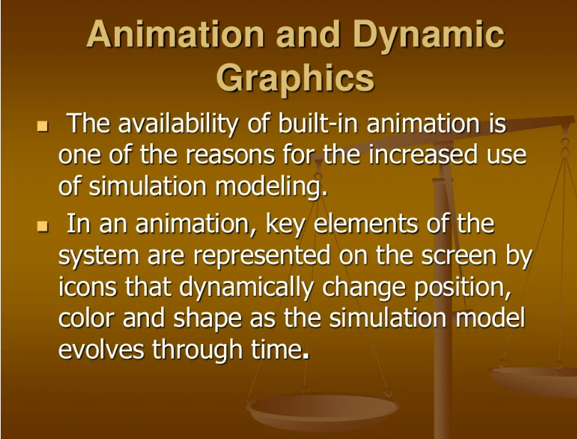

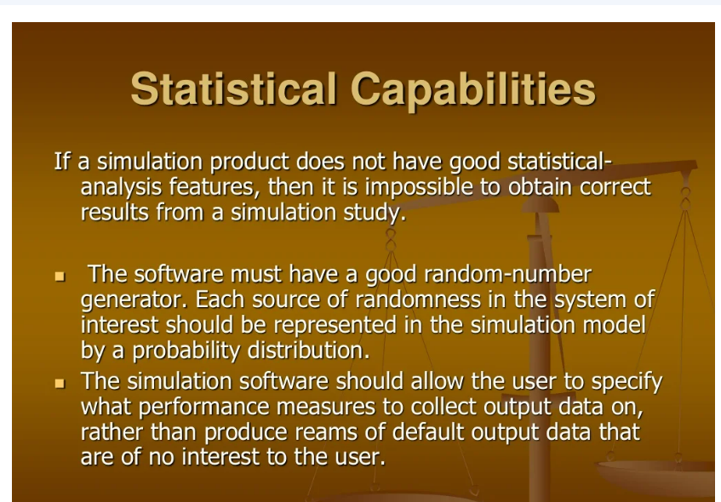

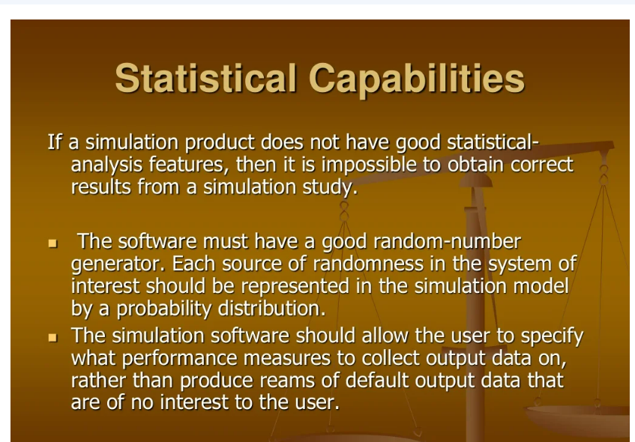 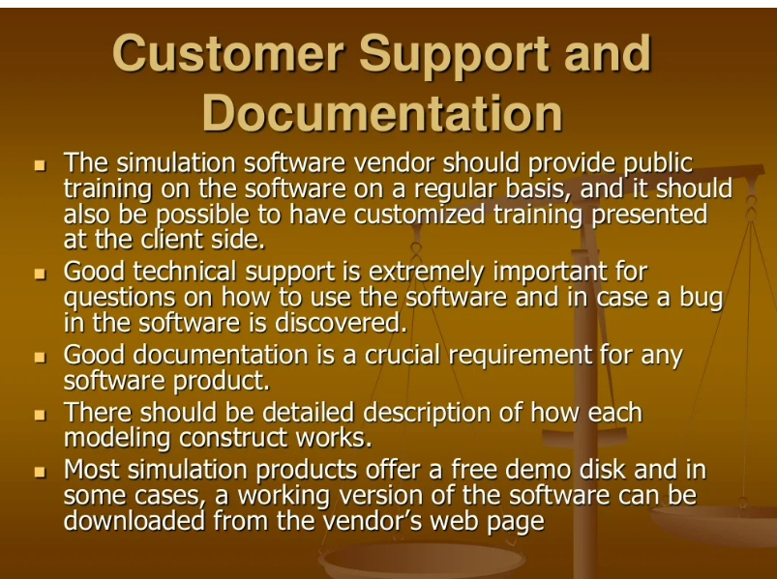 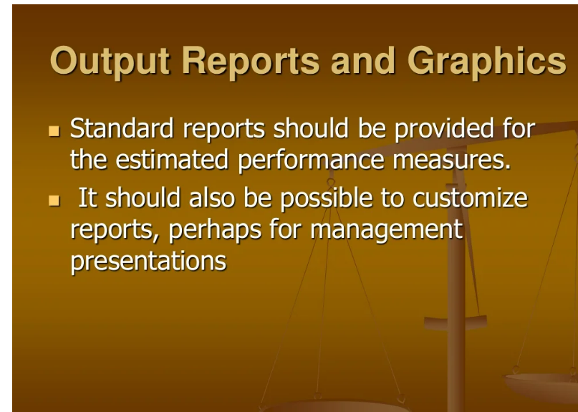 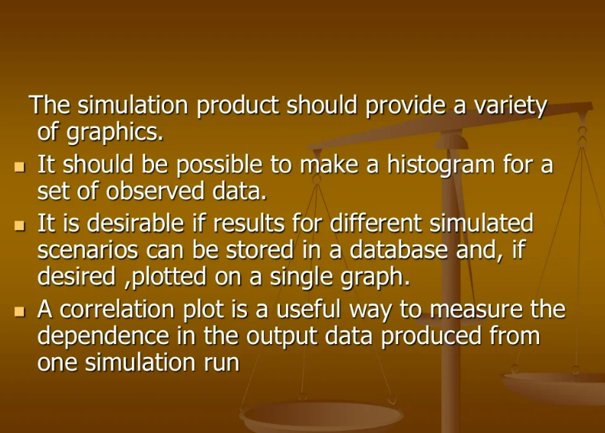

**Some popular simulation softwares**

* **Matlab**: **matrix laboratory** developed by MathWorks.**,** high-level programming language and interactive environment for numerical computation, visualization and programming.,
* matrix manipulations; plotting of functions and data; implement algorithms; analyze data; develop algorithms; and create models and applications.
* Signal Processing and Communications
* Image and Video Processing
* Control Systems
* Test and Measurement
* Computational Finance
* Computational Biology

Fusion 360:

* by Autodesk
* is a cloud-based 3D modeling, CAD, CAM, CAE, and PCB software platform for professional product design and manufacturing.

Simscale:

* CAE software ,
* The platform is cloud-based and provides instant access to computational fluid dynamics (CFD)
* The SimScale platform provides capabilities for solid mechanics, fluid dynamics and thermal analysis.

Blender

Simpy:

* a Python library that enables users to simulate real-life events.
* SimPy is a process-based discrete-event simulation framework based on standard Python.
* pip install simpy

Solidworks:

* SOLIDWORKS is used to develop mechatronics systems from beginning to end. Mechatronics, the combination of robotics, electronics, computer, and control systems,

Anylogic:

* multimethod [simulation](https://en.wikipedia.org/wiki/Simulation) modeling tool developed by The AnyLogic Company .
* It supports [agent-based](https://en.wikipedia.org/wiki/Agent-based_model), [discrete event](https://en.wikipedia.org/wiki/Discrete_event_simulation), and [system dynamics](https://en.wikipedia.org/wiki/System_dynamics) simulation methodologies

Sanskar Phet

Sandesh Blender:

* Blender is a free and open-source 3D creation suite that supports pretty much every aspect of 3D development.modeling, rigging, animation, simulation, rendering, compositing and motion tracking, even video editing and game creation.
* Blender is cross-platform and runs equally well on Linux, Windows, and Macintosh computers. Blender software is free and downloadable from its [official website](https://www.blender.org/download/).
* Blender software was developed out of the Blender Foundation, a nonprofit organization formed in 2002.